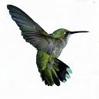

CONNECTING COMMUNITIES
“Your Change Will Make A Change”
Collecting Pennies, Promoting Hope
Helping children & families in rural Jamaica

KASSSI

Have you checked?
The back of your sofas
Old Purses
Old Wallets
Jackets
And that jar with your pennies!
Your Change REALLY DOES Make a Change!

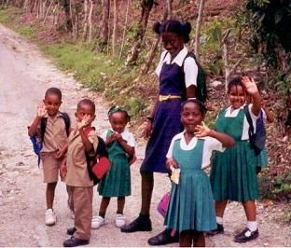

The work of KASSSI covers three main areas: Health, Social Welfare and Education; in order to enable greater independence and empowerment, thereby enhancing security, confidence and a better quality of life.
See www.kasssi.org/ or telephone 020 8778 6397 for further information

A one-off donation of £40.00 (for example) would enable a child to attend the Kings School Breakfast club for the entire school year (190 days)
No amount is too small! We are willing to collect each and every contribution!
